DIGITAL SEER TRANSCRIPT
Hello,
I am <<>>. I will be giving you walk through of Digital Seer app. This app has been developed to increase asset reliability & availability thereby reducing unnecessary maintenance.

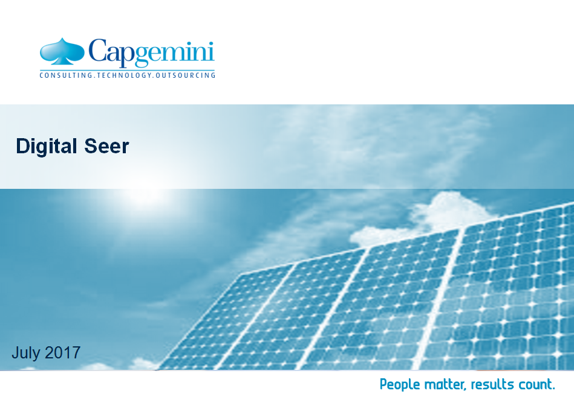
Solar energy is the most of abundant renewable energy source and its usage is growing at rapid pace resulting in better business and cleaner environment. Here are some statistics proving the growth of solar industry. Like other industries, solar industry is also posed with problems which affects the overall solar power generation.
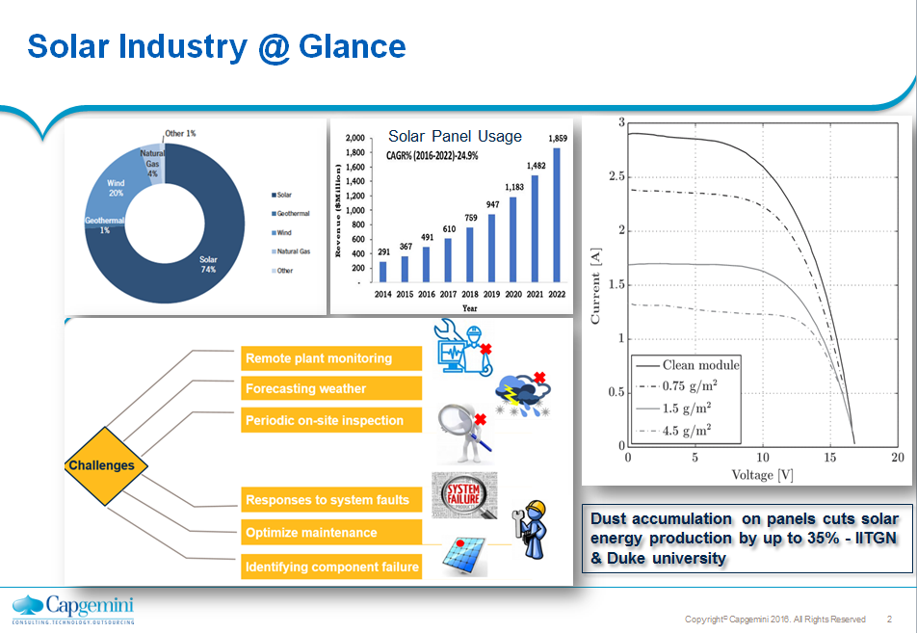
Cost of one inspection is $200-$300 which very high if there is no need of it. According to a study by IITGN and Duke University, solar energy generation decreases up to 25% due to dust accumulation. We do not have efficient remote plant monitoring systems in the market to monitor the performance of these assets.
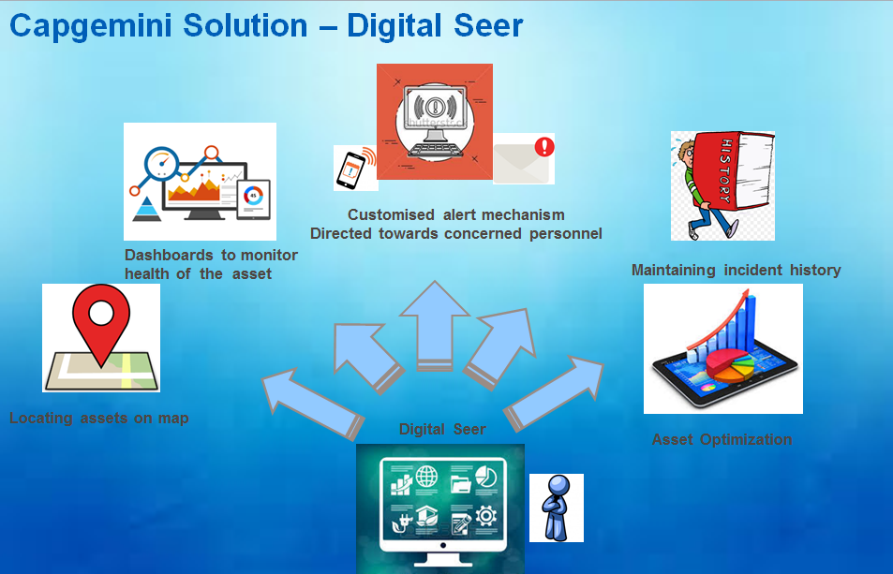

Our solution at capgemini helps in live tracking of the assets, monitor its health and most importantly, alerts the users in case of incidents/performance degradation. A feature of historical data capturing is also available which will help in monitoring previously generated incident . In future it will help in asset optimization.

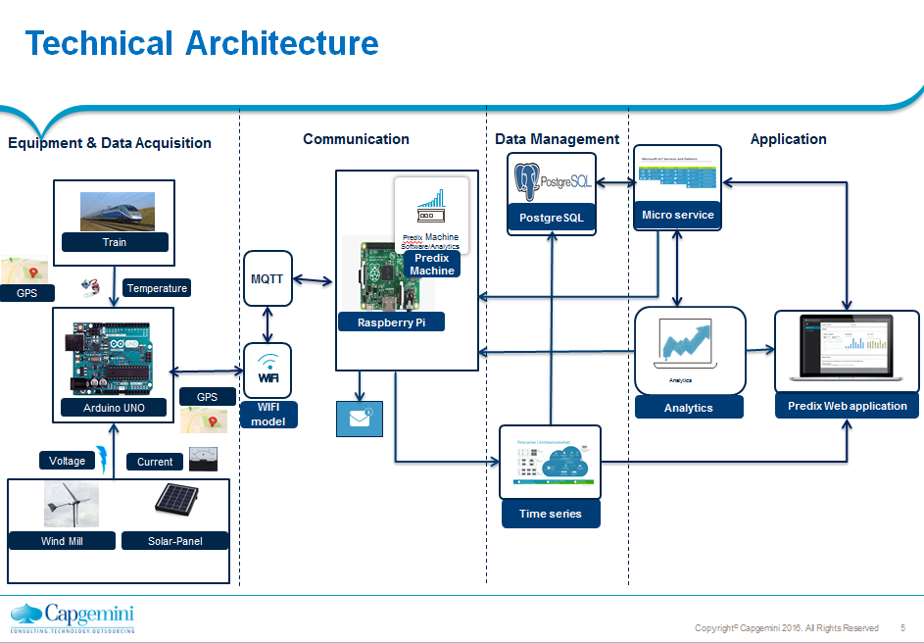
The architecture consists of 4 parts namely Equipment & Data Acquisition, Communication, Data Management and Application.

The sensors are mounted on the assets. The data from the sensors is captured using Arduino uno board and is sent to predix timeseries service via predix machine which is installed on Raspberry pi.

Let us have a quick view of Digital Seer application.
Click Launch DEMO

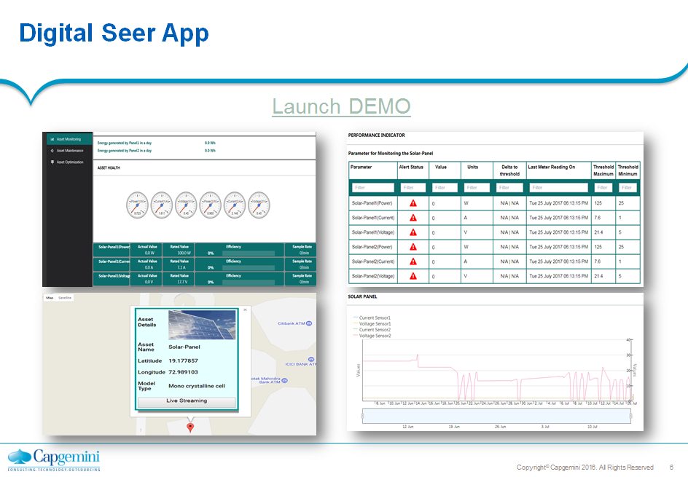

The application is developed as per maintenance manager’s perspective.
Asset Visibility.
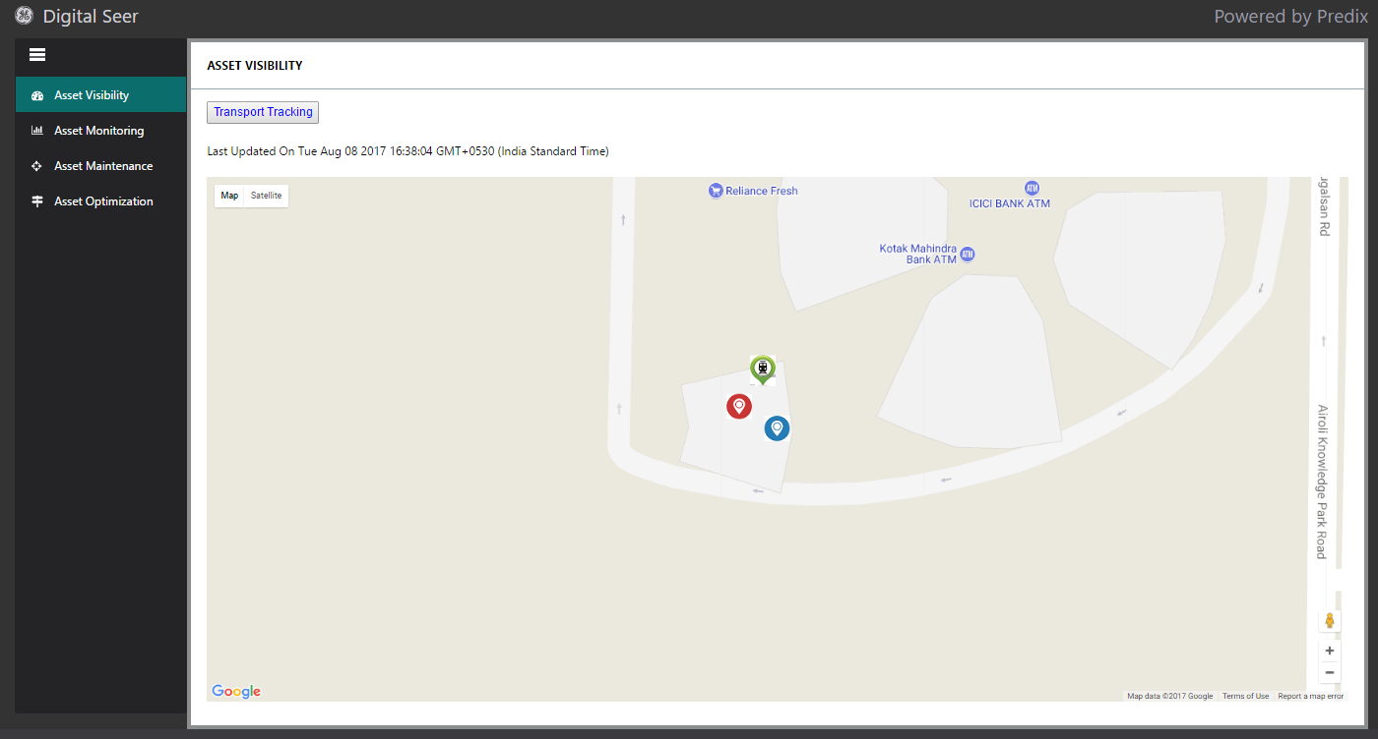
To showcase the wide scalability of the solution we are monitoring two types of assets
1)Energy i.e. Solar Panel & windmill both of which are mounted above . These are energy generating assets.
2)Transport i.e. Train . The energy generated by windmill and solar panel is being consumed by the train. Here at Digital Industrial lab we have created a mini model of the train to demonstrate its functionality.

This page gives the physical live tracking of the assets on google map along with a live timeseries graph.
How this solution work in real world (starts the train ) We have divided the track in 4 zones . As and when the train passes the zone we can have the exact zone of the train on application. Thus enabling us in having live tracking of the transport asset.

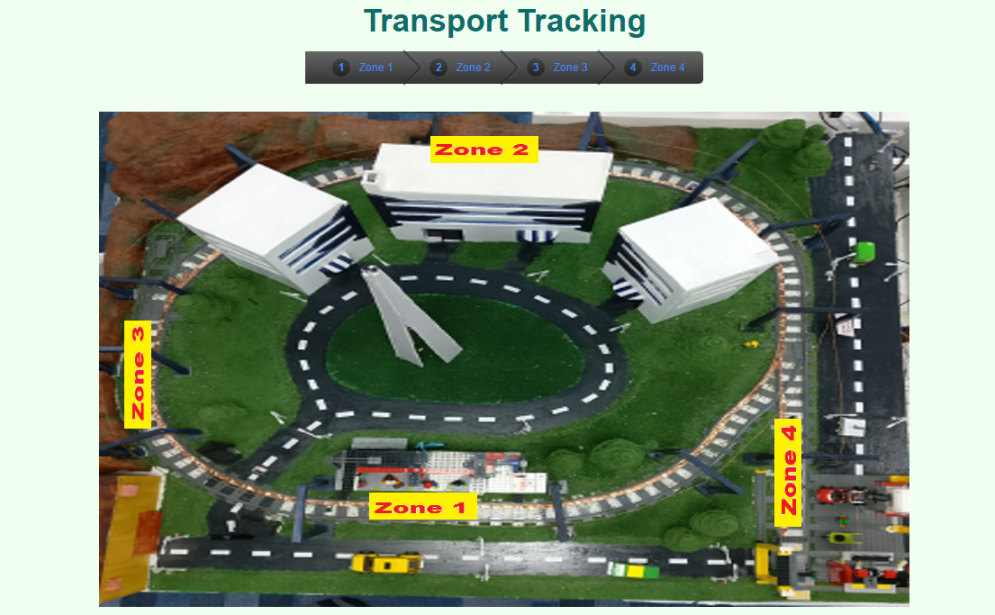

Asset Monitoring.

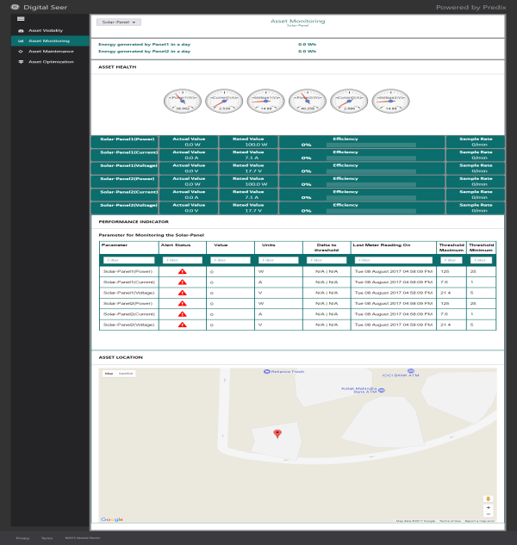

This page demonstrates different details related to the selected assets which help in its better monitoring. For Energy asset we have the total energy generated from midnight till the current time i.e. energy generated per day.
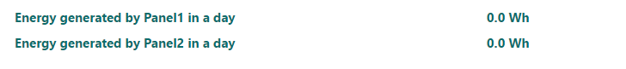
Here you can see the live data i.e. coming from the asset.
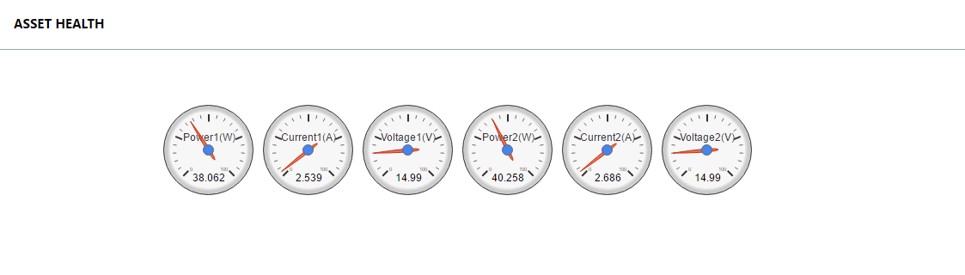

This shows the average parameter values and their comparison with the rated values along with the efficiency and sample rate. Efficiency is the % calculated with respect the actual and rated value. Sample rate give the rate at which the data is being retrieved from the predix service.
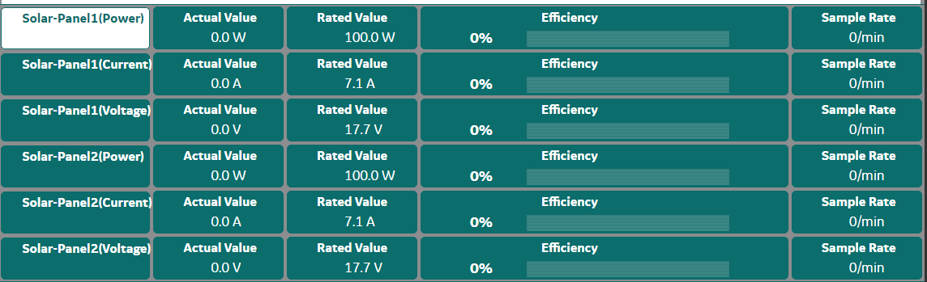

This grid is gives you a detailed insight of the parameters for monitoring the asset. Delta to threshold value is the percentage calculated of the difference between the maximum and minimum threshold values respectively.
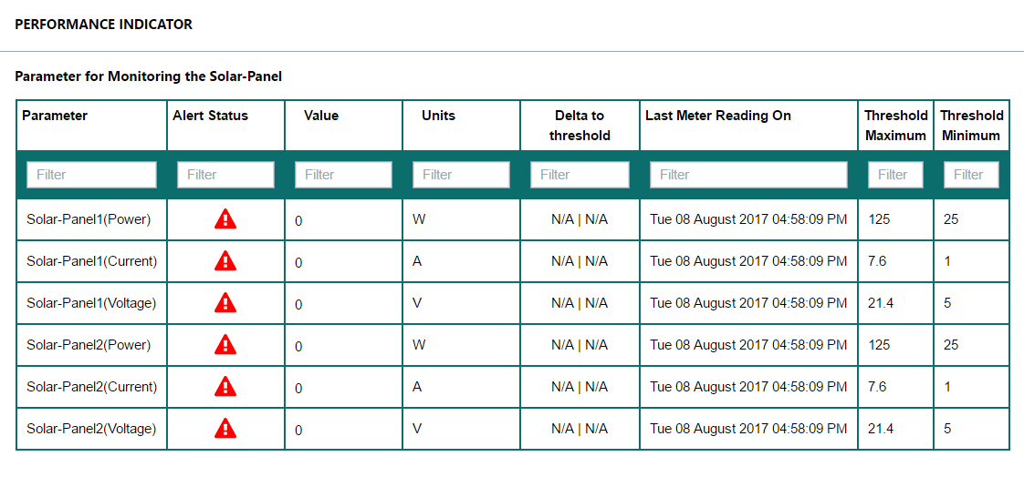

Asset Maintenance

This screen gives the history of the incidents generated in the past along with live alert mechanism in place which will give you the type of alert generated.
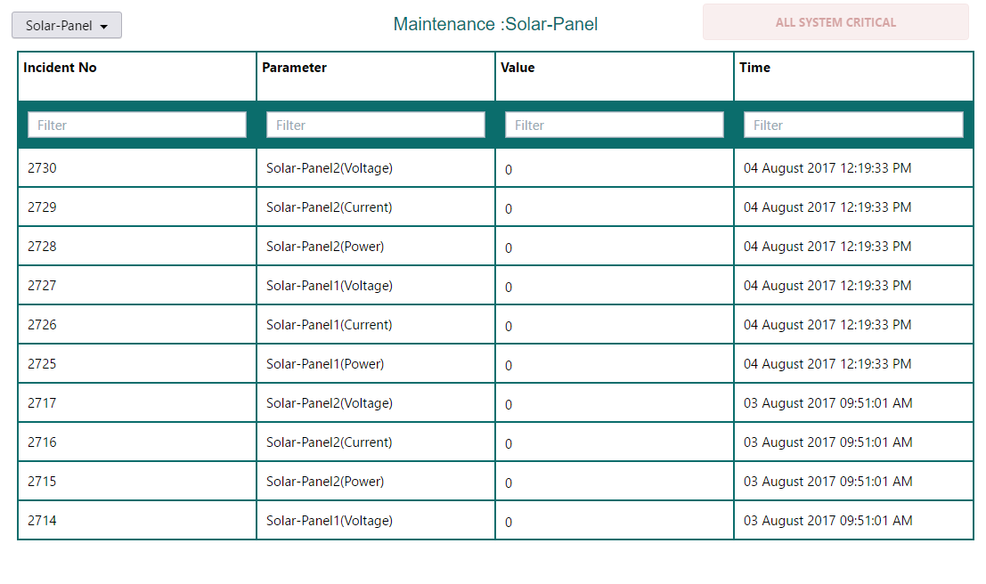

Whenever an alert is generated this table over here stores it along with live notification to be sent to the registered email id specifying customized alert message.

We are also planning on introducing the asset optimization feature to enhance the monitoring experience
Healthy assets are the foundation of a healthy business. This solution helps to enhance the business by proper monitoring of the assets.
